Junior Project
(PROGRESS REPORT#2)
Development of a Web-Based Course Allocation System for Faculty Members

Amna Al Shamsi U2114536
Asma Alali U22100601
Mahra AlKuhoori U22105880
Dana AlSafadi. U22200606

Project proposal for CS Junior Project
Computer Science
Supervisor:
Dr. Isam Al Jawarneh

College of Computing and Informatics
University of Sharjah

Introduction
Faculty members can now assign courses more quickly and easily thanks to the Web-Based Course Allocation System. It guarantees fair and transparent course allocations and lessens the Head of Department's (HoD) manual labor. The HoD, who authorizes final course assignments, and faculty members, who submit their teaching specializations and preferences, are the system's two primary users.

The technology matches teacher resumes to course needs using an AI-based algorithm and a web interface. This paper explains how the system functions and how the data and processes are arranged using class diagrams, ER diagrams, state diagrams, and sequence diagrams.
2. Behavioral Modeling
2.1Course Allocation Process (sequence Diagram)
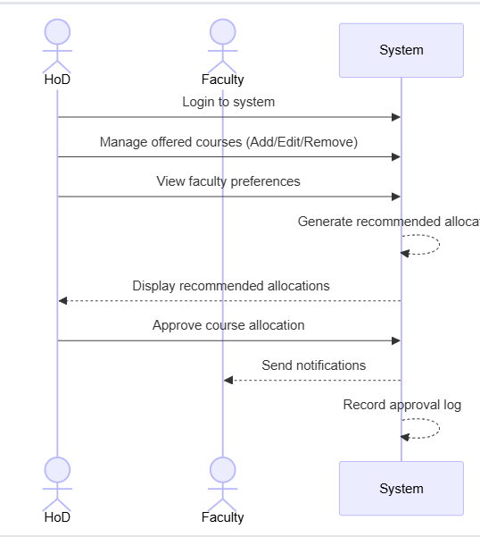
This figure illustrates how the system and the Head of Department (HoD) collaborate to assign courses. The HoD logs in, oversees the courses that are offered, and looks over faculty preferences. Faculty are notified and the approval log is kept once the system creates suggested allocations and the HoD approves the
2.2 Faculty Preference Submission
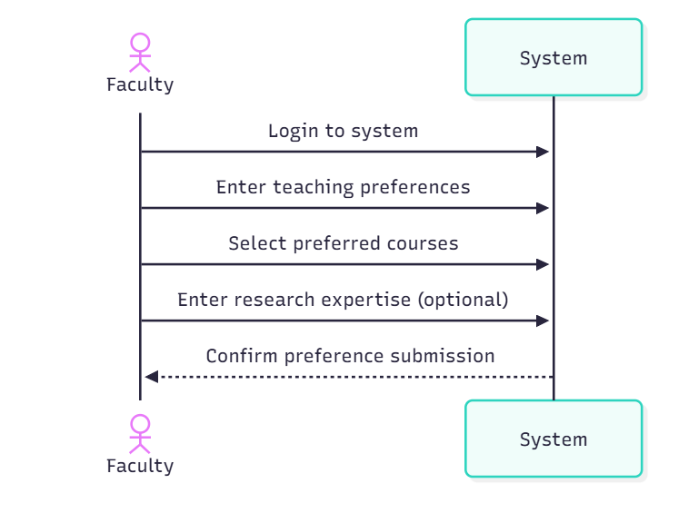
The process by which faculty members submit their preferred methods of instruction is shown in this graphic. Faculty members choose their selected courses, provide their teaching credentials, and optionally add their research experience after logging into the system. The preferences have been successfully submited, according to the system.

2.3User Management

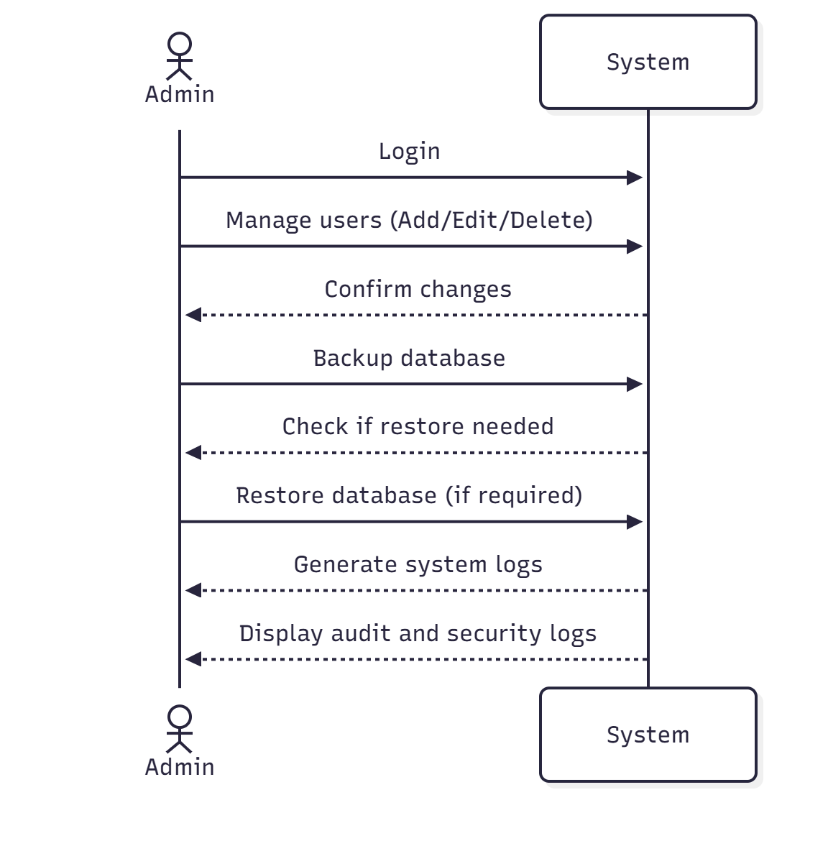

The administrator controls user and database actions, as seen in this diagram. In addition to managing user accounts and backing up the database, the administrator logs in and restores it as necessary. After that, the system creates system logs and presents audit and security logs for examination.

2.4Course Change Request
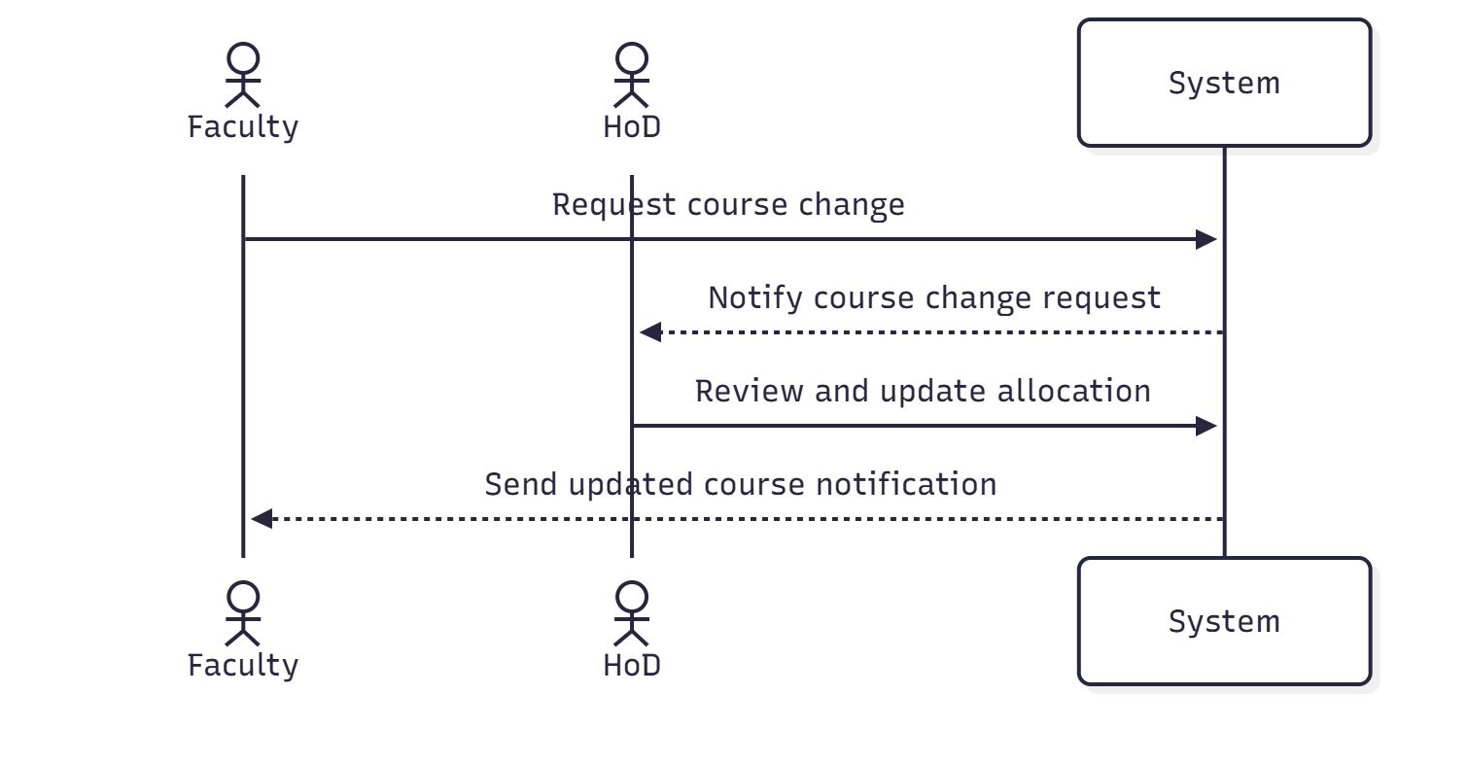

The process for teachers to request a course change is depicted in this figure. The HoD is notified when a faculty member files a request via the system. The system notifies the faculty of the amended course after the HoD reviews and, if required, modifies the allocation.

3. Structural Modeling
class diagram
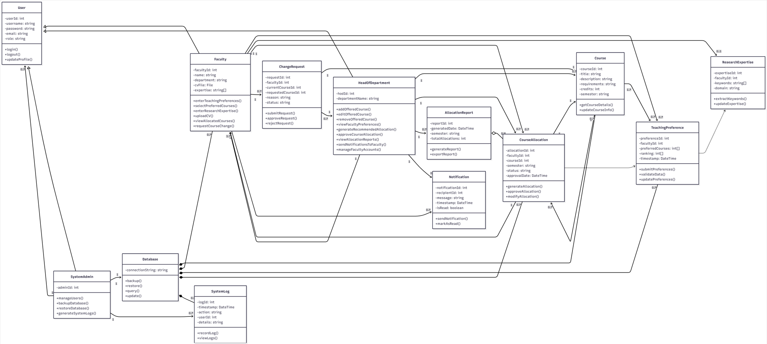

The Class Diagram represents a Course Allocation System, showing classes, their functions, and relationships:

User: Base class for all users.

Functions: login(), logout(), updateProfile()

Faculty: Manages courses, teaching preferences, research expertise, change requests, and notifications.

Functions: managePreferences(), updateExpertise(), viewAllocations(), submitChangeRequest(), viewNotifications()

HeadOfDepartment (HoD): Oversees courses, allocations, reports, and communicates with faculty.

Functions: manageCourses(), approveAllocations(), generateReports(), sendNotifications()

SystemAdmin: Handles users, database, and logs.

Functions: manageUsers(), backupDatabase(), restoreDatabase(), viewLogs()

Course: Represents courses offered.

Functions: getDetails(), updateInfo()

TeachingPreference: Faculty teaching choices.

Functions: setPreference(), viewPreference()

ResearchExpertise: Faculty research areas.

Functions: addExpertise(), viewExpertise()

CourseAllocation: Connects faculty to courses.

Functions: assignCourse(), viewAllocation()

ChangeRequest: Faculty requests for allocation changes.

Functions: submitRequest(), reviewRequest()

Notification: Sends updates to faculty and HoD.

Functions: sendNotification(), viewNotification()

AllocationReport: Summarizes course allocations.

Functions: generateReport(), viewReport()

SystemLog: Tracks system activities.

Functions: logAction(), viewLog()

Database: Stores all system data.

Functions: storeData(), retrieveData()

Relationships:

Faculty links to multiple TeachingPreferences, CourseAllocations, ChangeRequests, and Notifications, and one ResearchExpertise.

HoD manages multiple Courses, CourseAllocations, AllocationReports, and Faculty.

CourseAllocation connects one Faculty and one Course.

SystemAdmin manages Users, SystemLogs, and Database.

Database contains Courses, Faculty, Preferences, Allocations, and Logs.

AllocationReport summarizes multiple CourseAllocations.

Preferences depend on Expertise, and Allocations depend on Preferences.

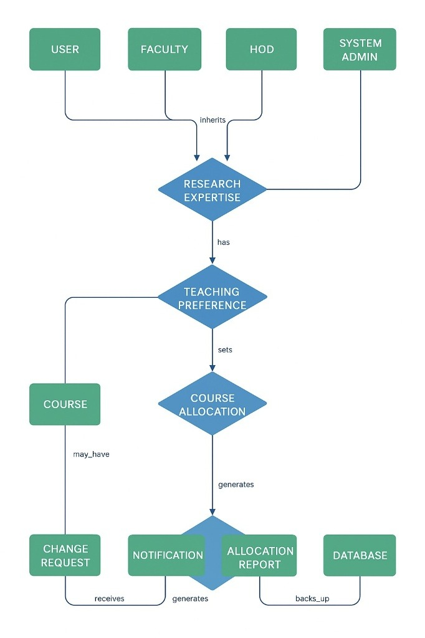
4. Data Model
4.1 ER Diagram

This ER diagram illustrates how various The Course Allocation System's workflow is depicted in this ER diagram, with USER serving as the primary base entity and several user types (Faculty, HOD, and System Admin) inheriting from it. Teaching preferences are determined by the research expertise of the faculty and HOD. Course Allocation, which determines which faculty member teaches which course, is created using these Teaching Preferences. If changes are required after the allocation, a course may have a Change Request. The system creates an official Allocation Report and Notifications to notify users once course allocation is complete. After then, a backup of this allocation report is made and kept in the database for future reference and record-keeping.

5.state Diagrams
5.1Faculty authentication and profile maintaining

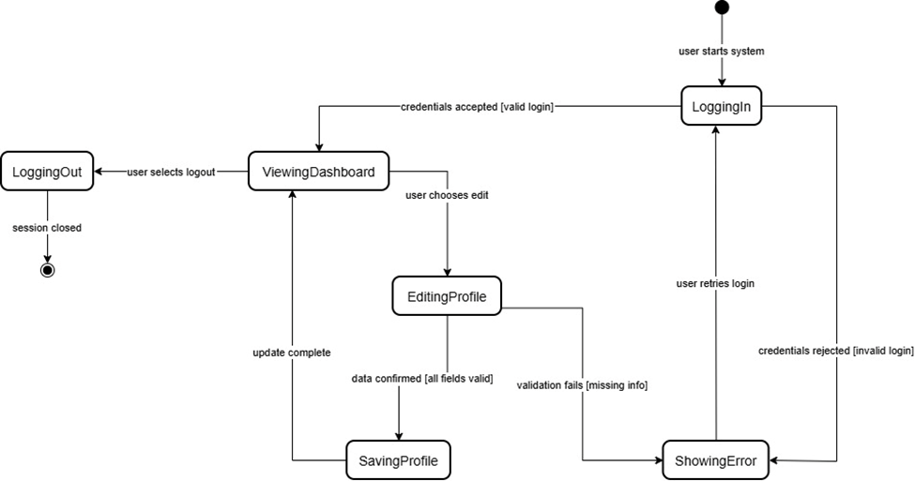

This state diagram illustrates what happens when a faculty member wants to change a course assignment. First, they decide which of their assigned courses they want to change. They make a change request, provide a rationale, and occasionally present an alternative. The system forwards the request to the HoD after reviewing it. If the HoD gives the go-ahead, the system changes the professor allocation. If not, a notification is sent to the faculty member and nothing happens.

5.2 Faculty preference submitting

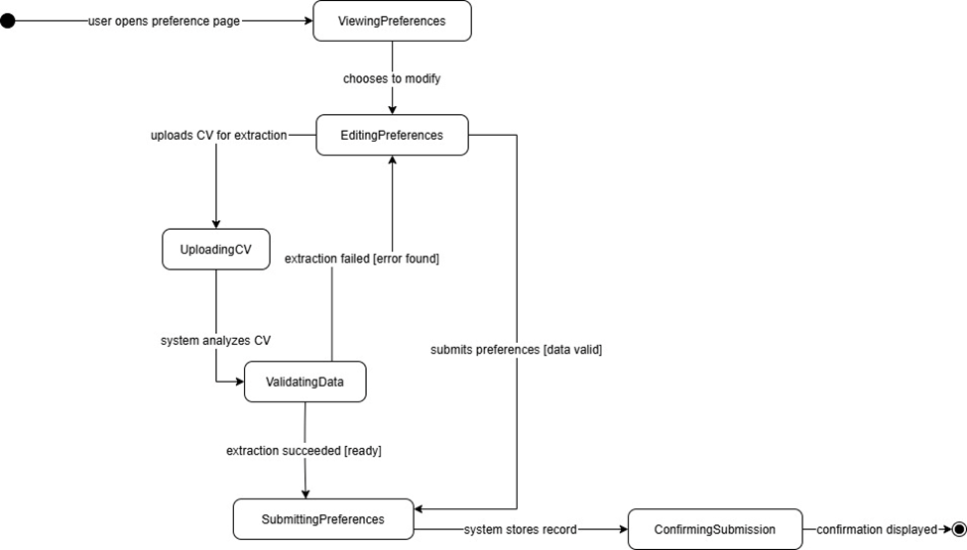
How a faculty member presents their preferred methods of instruction is depicted in the diagram. They start by opening the preference form after logging in. They select courses based on their interests and areas of expertise. The form is verified by the system to ensure that all fields are filled out. It notifies the faculty member to make the necessary corrections if anything is lacking. They click submit once everything appears to be in order. The system verifies that the submission is complete and saves the data.

5.3 course changing request(faculty)

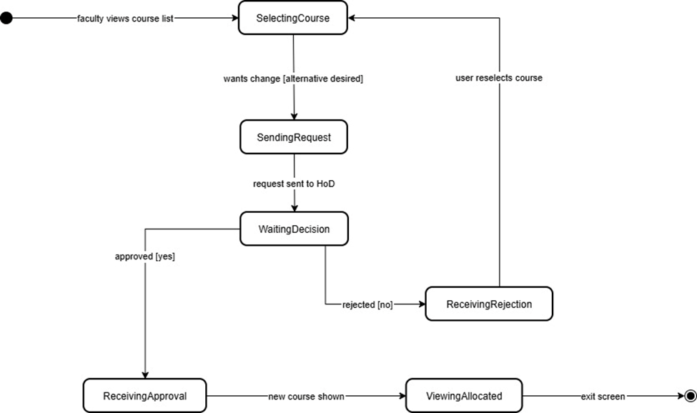

This state diagram illustrates how a faculty member can request a modification following course assignment. The faculty members begin by looking at the courses they have been assigned and choosing the one they wish to change. After that, they file a change request with the explanation or suggested substitute. After reviewing the request, the system sends it to the HoD for approval. The system modifies the professor allocation if the request is approved by the HoD. The faculty is informed and the allocation stays the same if the request is denied.

5.4 Allocation generating and approving (system & HoD)

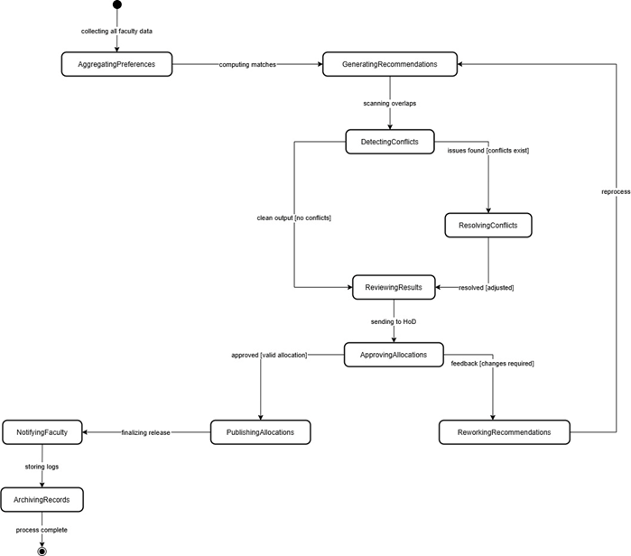
This state diagram maps out what happens when a faculty member wants to change a course assignment. First, they look through their assigned courses and pick the one they want to swap. They send in a change request, add a reason, maybe suggest a replacement. The system checks the request and forwards it to the HoD. If the HoD gives the green light, the system updates the professor allocation. If not, the faculty member gets a notification, and nothing changes.

5.5Course offering managing (HoD)
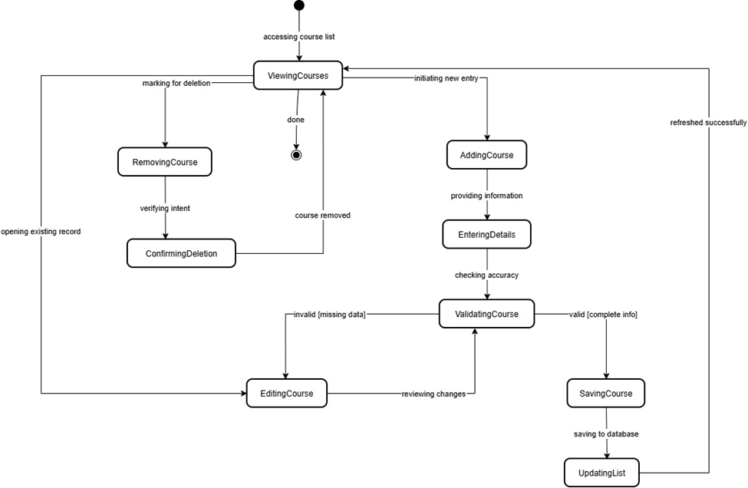

What occurs when a faculty member wishes to modify a course assignment is shown in this state diagram. They first choose which of their designated courses they wish to switch. They submit a change request, include a justification, and sometimes offer an alternative. After reviewing the request, the system sends it to the HoD. The system modifies the professor allocation if the HoD gets the go-ahead. If not, nothing happens and the faculty member receives a notification.

5.6 Admin backup
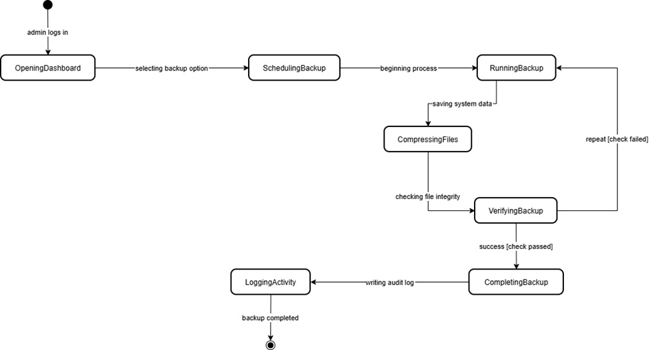
This state diagram illustrates what happens when a faculty member wants to change a course assignment. First, they decide which of their assigned courses they want to change. They make a change request, provide a rationale, and occasionally present an alternative. The system forwards the request to the HoD after reviewing it. If the HoD gives the go-ahead, the system changes the professor allocation. If not, a notification is sent to the faculty member and nothing happens.

6.Summary
The design and modeling stage of the Web-Based Course Allocation System, which attempts to automate and streamline the process of allocating courses to faculty members in a fair and effective manner, is the subject of this second study. This phase presents comprehensive diagrams that show the structure and behavior of the system, such as state diagrams, class diagrams, sequence diagrams, and an ER diagram, building on the requirements and analysis established in the preceding report. These models specify how users, including the system administrator, faculty members, and the head of department, interact with the platform, control preferences, authorize allocations, and save backups. In order to ensure precise and transparent allocations, the system incorporates an AI-based matching algorithm that analyzes faculty resumes and course descriptions using ChatGPT. All things considered, this report shows a great deal of progress in moving from conceptual design to system architecture, setting the groundwork for the future phase's implementation and integration phases.
7.Challanges faced
-Transforming actual academic procedures into precise visual representations (ER, state, sequence diagrams) is challenging.

-The modeling became more complicated because different user roles (Admin, HoD, and Faculty) needed different flows and permissions.

-To prevent logical contradictions, it was necessary to carefully analyze the relationship between research expertise → teaching preferences → course allocation.

-The complexity of the system rose when both automated allocation and manual change requests were handled.

-Due to the ongoing development of the AI-based matching algorithm during the construction of the diagrams, time constraints emerged.

-It required more revision and verification work to guarantee consistency across all diagrams (class, ER, state, and sequence diagrams).

